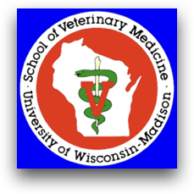
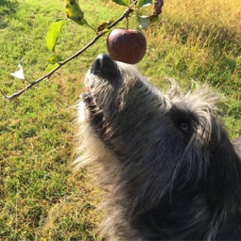
Irish Wolfhound Osteosarcoma

LOOKING FOR PARTICIPANTS
The Comparative Genetics Laboratory at the University of Wisconsin Veterinary School is beginning a new project investigating osteosarcoma in the Irish Wolfhound, specifically focusing on young dogs.

We are interested in what specific genetic component of osteosarcoma in Irish Wolfhounds makes this condition so prevalent in the breed. We are actively writing grants for this work, and need to start collecting samples so when funding becomes available, we can start on day 1!

Studying diseases in rare breeds is difficult, but new technologies are providing opportunities to investigate the genetic basis of diseases with fewer dogs that has historically been needed. We are looking to collect blood samples from a select number of Irish Wolfhounds. These blood samples need to be collected specifically for this study due to the advanced technology that we will be using for this work. We are also seeking pedigrees of any Irish Wolfhound, particularly when it is known whether dogs/relatives have or have not developed the osteosarcoma.

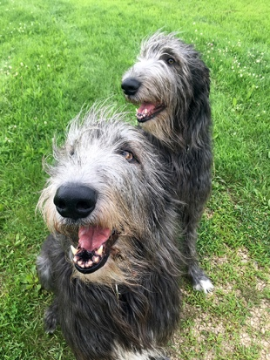
Specifically, we are seeking:
1) Purebred Irish Wolfhounds who have developed osteosarcoma before the age of 5. If either (or both) parent is available to donate a blood sample, this would be of substantial value. For dog’s having limb amputations, we may ask permission to have your veterinarian collect tissue samples after limb removal.
2) Purebred Irish Wolfhounds over 10 years of age who have not developed osteosarcoma.
3) Pedigrees of families with individuals that have known osteosarcoma disease status or known age and cause of death

We can have samples shipped to our laboratory, so you are not required to come to the University of Wisconsin for participation. We appreciate that not all dogs have an official “tissue diagnosis” of osteosarcoma; this is not a problem if there is radiographic evidence of disease.

Participation is free, and we are not asking for monetary donations. For owners/animals not able to come to UW-Madison, we cover all costs associated with visiting your family veterinarian, a blood draw and shipping. We will provide your veterinarian with everything needed. We regularly work with veterinary practices to ensure that the process minimizes the burden on owners and their pets!

We would be grateful if you have a dog or know of dogs/litters that could participate in this work. All identification will remain confidential, as we understand this can be a sensitive issue.

The best way to contact us is through e-mail: genetics@vetmed.wisc.edu or by phone: (608) 265-5828. Alternatively, you can contact us through our Facebook page at http://www.facebook.com/SVMgenetics

Please consider joining our Team as we start to investigate the genetic basis of osteosarcoma in young Irish Wolfhounds!!

