SAMPLE PREPARATION
What tissues should I trim off the globe?
Remove all tissues you don’t need us to evaluate.
If there is an intraocular tumor and you’re worried about surgical margins, we recommend you leave the extraocular tissues attached (and please tell us where the tumor is located). Marking lesions with sutures is nice if you like (and please explain the sutures). We endeavor to evaluate the optic nerve on all cases, so please leave it attached.
Here’s an example of a well-trimmed globe:
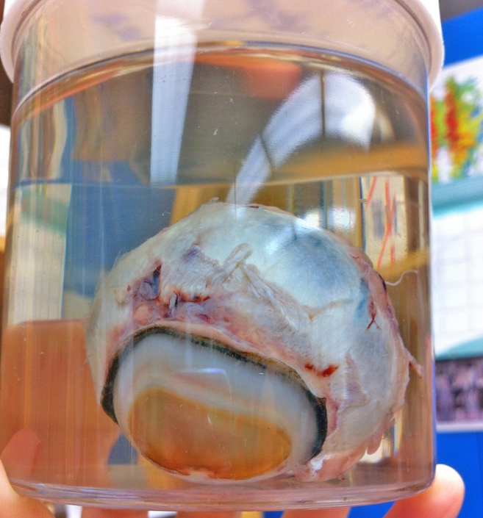

How should I preserve my specimen?
All samples should be immersed in ten times their volume in 10% neutral buffered formalin 24-48 hours before mailing to us.
If you want to remove formalin for shipping, pack formalin-soaked gauze around the specimen for shipment (after the specimen has been immersion fixed for 24-48 hours).
Though Davidson’s solution provides beautiful preservation of the retina and lens, we actually prefer 10% neutral buffered formalin for routine samples. If you are sending research samples for which you’re exquisitely interested in the retina or lens, then please discuss with one of the pathologists whether Davidson’s is an ideal choice.

Should I poke a hole in the globe or inject formalin into it?
No! Please leave the globes intact and do not inject anything into them.

How should I send small samples, especially cornea?
We recommend putting small samples into cassettes and then placing them into formalin. We prefer the “mesh” cassettes with very small holes, but a regular cassette with a formalin-soaked blue sponge works well too. Make sure that the cassette fills with formalin and sinks when you place it into the container for good tissue fixation. Please don’t squish tissues in cassettes between two blue sponges – this induces artifact and can ruin a sample.
For conjunctival or corneal samples, we recommend laying them onto a piece of paper or thin cardboard (index card), allowing them to dry for ~ 5 minutes and then dropping them attached to their substrate into formalin. This helps prevent tissue curling, which helps with trimming and embedding the specimen. You can use a pencil to label the paper/card to indicate various parts of the sample, which may help us with tissue orientation when we are trimming it in.

How should I note where my lesion of interest is?
You can include a drawing on the submission form. You can explain with words (“dorsomedial iris” or “ventral ciliary body” etc). You can also put a suture into the episcleral tissue overlying a particular lesion – and then please explain why you’ve placed the suture. Remember that a mass or other lesion may be obvious to you clinically, but once the globe has been fixed, we may not be able to locate it through the cornea or locate it in the cornea (for ulcers etc).

If I have a sample from an exotic animal, should I do anything differently?
You may use the normal COPLOW submission form. Sample preservation is the same as tissue from a domestic animal. We may offer a discounted fee for samples from exotic animals – please contact the lab and speak to a pathologist.

What if I want to submit a clinical photograph?
Please email clinical photographs to the coplowfellow@vetmed.wisc.edu email account and include the patient’s name and owner’s last name. We love photos!

How do I get a second opinion from COPLOW on a case that was initially submitted elsewhere? And how much does it cost?
Please ask the initial diagnostic lab to send 4 unstained slides or the paraffin block directly to COPLOW (address on our submission form). If they send the paraffin block, please have them specify if they need to have it returned and include instructions for how to do so. Some diagnostic labs will not send directly to COPLOW and will only send slides/blocks to the requesting veterinary clinic, who will need to then send the slides/blocks to COPLOW. Please also fill out the COPLOW submission form and provide relevant clinical information. We also like to get a copy of the initial histopathological results. The cost of COPLOW providing a second opinion is $50.

SHIPPING
How should I package my sample?
Formalin jars with specimens should be put into a Ziploc bag. The submission form should be placed into a separate Ziploc bag to avoid formalin leaking onto the form. These items should then be surrounded by packing material (newspaper, brown paper, bubble wrap) in a cardboard box (not an envelope). Jars can be crushed in envelopes, resulting in destruction or loss of your precious specimen and leakage of formalin, which is hazardous.
Below is a sad example of a jar that was mailed in an envelope and was broken during shipping. This can even happen with the padded FedEx or UPS envelopes – we highly recommend a cardboard box!
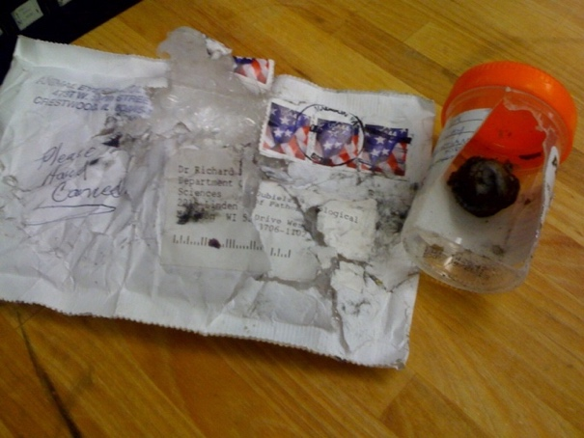
How can I prevent freezing of my sample during the frigid winter months?
Remember COPLOW is in Wisconsin and it is possible for samples to freeze during the winter months (November through March). Please add 10% of the jar’s volume of alcohol to the jar with formalin. Either 70% ethanol or 70% isopropyl alcohol will be fine. As an example, a formalin jar that contains 30 ml of formalin should have 3 ml of alcohol added. A 100 ml jar of formalin should have 10 ml of alcohol added.
Here is an example of a frozen globe. This induces terrible microscopic artifact that can preclude our ability to make proper diagnoses. You don’t want this to happen to your precious specimens!

What shipping service can I use?
Any service you like! We recommend getting and keeping tracking numbers for each package you send. The cheapest option will likely not get the sample to us in a timely fashion, which will delay getting results.

Can I send samples from another country? Do I need to take them out of formalin first?
The legality and logistics of shipping formalin-fixed biological specimens varies by location and you should contact your local shipping agency/company to ask for the regulations and recommendations. We may need to help facilitate shipping specimens from our end - please call us or send an email (coplowfellow@vetmed.wisc.edu) to discuss. It’s best to allow the specimen to fix for 24-48 hours immersed in formalin and then send it with formalin-soaked gauze to avoid formalin leakage.

BILLING
How can I pay?
COPLOW can no longer accept checks for payment that are mailed with samples.
The University of Wisconsin (and thus COPLOW) is transitioning to a new Accounts Receivable system in the summer of 2021. All balances will be billed digitally through your provided email address, or (less preferably) a paper invoice will be sent to a street address. Checks will be accepted for payment of an invoice, but they will be sent to a different address than before (in Milwaukee rather than Madison). The new address and additional information about how to pay a bill with the new system will be included in each invoice. There is no need to set up a billing account before sending a submission, but when you submit a sample, please include an accurate mailing address and email address where bills can be received. Credit cards (American Express, Visa and Mastercard) will continue being accepted for payment.

How long will it take to get results?
Once we receive the sample, our average turn-around time is about 3 days. Some cases require deeper sections of the blocks or special stains, which may take a few days longer. Please keep in mind your shipping method and estimated time for delivery when thinking about when to expect results from us. The tracking numbers can help you to estimate delivery date and thus when you should expect results.
If you have a case that you would like to be run “STAT,” please indicate that on the form and explain why you would like expedited results.

How much does it cost to get samples analyzed?

Service | Price
Tissue (non-globe) | $100 for up to 3 locations. For additional locations, we will add $10 / location
Small animal globe (dog, cat, small exotic) | $120
Large animal globe (horse, cow, small ruminant, etc) | $130
Second globe (same animal) | $20  Can be submitted at a different time as the first globe, but must include the previous COPLOW case # (RD#) to qualify
Second opinion | $55 if an unstained slide is submitted, $70 if paraffin block is submitted. Will be adjusted if two or more different unstained slides or paraffin blocks are submitted.
Copies of slides for your own collection | $15 / regular sized slide, $20 / large slide  If tumor margins are evaluated, we will choose a single representative slide to send a copy of.

